PIC Tutorial Hardware - Extras

OUTPUTS
I've added this page to give a few extra simple interfacing examples, the PIC itself inputs and outputs logic level signals, for the purposes of these tutorials we can consider a 'high' output to be 5V, and a low output to be 0V. If you check the PIC datasheets, you will find that the output pins can actually 'sink' or 'source' a reasonable amount of current - about 25mA or so. 'Sink' means that the chip 'sinks' current down into itself, so the load is connected from the positive rail to the I/O pin and the load is switched ON by the pin going 'low'. 'Source' is just the reverse, the I/O pin is the actual source of the current, and it flows out of the pin, through the load down to ground - in this case the load is switched ON by the pin going 'high'.
Most of the examples in the tutorials use simple LED's, the 25mA capacity of the PIC is more than sufficient to provide this current, so all that's required is the LED itself, and a simple current limiting resistor - connecting the LED without a resistor is likely to damage both the LED and the PIC!. The two examples below show how to connect an LED in either 'sink' or 'source' modes
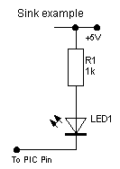 | 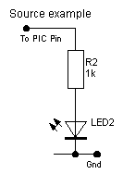
This is how to connect an LED for the PIC to SINK current.  The LED will light when the PIC pin is low. | This is how to connect an LED for the PIC to SOURCE current.  The LED will light when the PIC pin is high.
This is fine for lighting an LED, but for heavier loads such as relays, motors etc. the 25mA current capacity of the PIC is too low, so we need a slightly more complicated system to give greater capacity. Probably the simplest way is to use a switching transistor, and, just as with the previous example, we can 'sink' or 'source' the output. These first two transistor examples show a small lamp being switched.
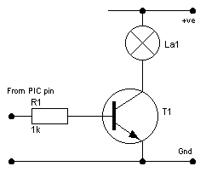 | 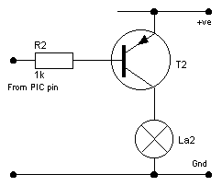
'Sinking' current from a lamp. | 'Sourcing' current to a lamp.
The 'sinking' example is probably the easiest to understand, as the PIC pin goes high current flows through R1 turning the transistor ON, effectively connecting the bottom end of the lamp to ground. This method has a rather useful property, the +ve supply to the lamp isn't related in any way to the supply voltage of the PIC, so you could quite happily have the PIC fed from 5V, and a 12V supply feeding the lamp, you just need to make sure that they share a common 0V or Gnd connection.
The 'source' example is effectively the same but upside down, while the PIC output is high no current flows through R2, so the transistor is turned OFF, as the PIC pin goes low current flows through R2 as before turning the transistor ON. This effectively connects the top of the lamp to the +ve supply. Unlike the 'sink' example, this simple 'source' circuit must use the same supply as the PIC - because for the PIC to turn the transistor OFF it's output must go as high as the +ve supply to the emitter of the transistor.
The previous example showed switching a lamp, which is a nice 'easy' load to switch as it's non-inductive. A very common application though is to switch a relay, which is an inductive load - this requires an extra component, a simple diode across the relay coil to prevent the transistor failing. When you switch an inductor OFF it causes a high back EMF to be formed, this could be several hundred volts, and will most probably destroy the transistor. By fitting a reverse biased diode across the coil, this back EMF will be safely 'dissipated' without damaging the transistor. I've only shown a 'sink' example here, and I've specified a 12V supply for the relay, this would be a fairly typical use - switching a relay in a car for example. There are a number of advantages in using a relay - firstly it gives a high current and voltage switching capability, secondly it provides isolation between the PIC circuit and the load. As far as disadvantages go, a relay is fairly large, very old technology, and quite slow in operation. But for a great many purposes a relay is the ideal solution. | 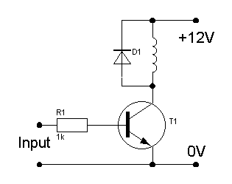

The relay example above SINKS the current, so there's no problem with a 12V relay, and the PIC running off only 5V. But if you need to SOURCE a 12V switched supply you require an extra transistor. This circuit adds a PNP transistor, switched by the NPN transistor which is fed from the PIC. This isn't limited to only 12V, it works just as well with a higher voltage supply - but the transistors must both be rated to work at the voltage used. | 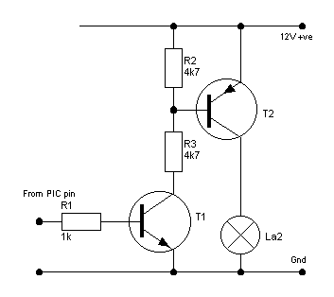

INPUTS
Inputs to a PIC have the same 5V logic requirements, and just as outputs can be 'sink' or 'source', so the inputs can be active 'high' or active 'low'. Basically this is just a variation on the same theme - but, depending on the actual input device, you may be forced to use a particular method.
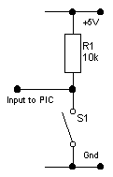 | 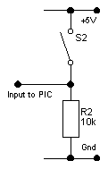
Active LOW | Active HIGH
These are the two basic input alternatives, the 'Active LOW' example is the most common, simply because the MicroChip PIC's usually have selectable 'weak pullups' on some ports - so you don't always even need the 'pull up' resistor R1. This is the configuration I've used in the tutorials, although I include the 'pull up' resistors so you can use them on any port. It's very easy to understand, the resistor R1 'pulls' the PIC input high (logic '1') - when you press the switch it pulls the voltage down to zero, changing the input to logic '0'.
The 'Active HIGH' example works in the opposite way, R2 is a 'pull down' resistor, holding the PIC input at logic '0', pressing the switch connects the PIC input to the 5V rail, forcing it to logic '1'.
In these first two examples I've shown switches (S1 and S2), but these could just as easily be a switching transistor, or the output from an IC, or simply an output pin from another PIC.
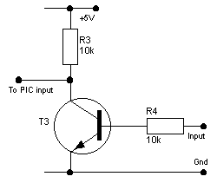 | 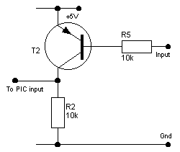
Transistor switching LOW | Transistor switching HIGH
These two examples show how to use a switching transistor on the inputs, due to the inverting action of the transistors, the left hand example pulls the PIC pin LOW when the input to the transistor is HIGH. The right hand example pulls the PIC pin HIGH, when it's input goes LOW. A very useful effect of the left hand example is that the input doesn't need to be a 5V logic signal, it could easily be a 12V signal (or higher), the action of T3 converts the input to a nice 5V signal for the PIC - as long as the input to T3 is high enough to switch T3 ON.
A useful feature of the PIC inputs are the 'protection diodes', these clamp the input to the +VE supply and GND, preventing the input going above +VE or below GND. This means you can feed a higher voltage into the input, with just a simple current limiting resistor, MicroChip have an application note for a light dimmer, where the incoming mains is fed via such a limiting resistor straight into a PIC input pin - used to detect the zero-crossing point of the mains. The 16F628 datasheets quotes the maximum 'clamp current' through the diodes as 20mA, but I would suggest keeping it far lower than that, it's a high impedance input so we don't require much current through the limiting resistor.

